* Entity-Relationship (E-R) Diagram of the complete database scheme
* Lucid description of the relational database scheme of the social networking site database, including a discussion of the reasoning behind your design decisions. Make clear how your design supports efficient query processing.
* A list of all functional dependencies in the relational database scheme
* Description of integrity constraints, including referential integrity

You will also be required to submit a *Users Guide* that carefully explains how to use all aspects of the system. It should be understandable by non-computer experts. Be sure that the user interface (screen design, menu structure, etc.) is clearly explained.

**E-R Diagram**

The preferences attribute set is tied to the user, not to the account. Here, the account means the credit card account. A user can have several associated credit card accounts, with each account having its own transaction history. However, a physical person is not supposed to register with more than one user name, because each person will have a unique SSN. We did not build any table that maps from one SSN to several usernames. Further, the same user name will be associated with the same person regardless of the role they play.

**Relational Database Scheme/Design Process for Efficient Query**

Even though the demo data for the account section included many more attributes, we parsed it out to only have two columns. Similar things was done with the User table. The reason was the follow reduce redundant functional dependency to avoid update anomaly and deletion anomaly. We know that if we make irrelevant attributes such as preferences attributes sets as part of the User primary key, we run into problems when any of the preferences field is null. Further, every time we want to update any user information, all of the entries in the User table with a different preferences has to be update as well. If repetitive functional dependency was not avoided, then it would lead to significant query inefficiency.

It’s also worthy to note that Stony Brook’s SQL host connection only allows up to about 20 connections simultaneously. Therefore, our project must be especially sensitive to the load it puts on query transaction.

As for the security aspects, URL parsing has been one of the hardest attack vector to defend against. Suppose our main URL is [www.royalhuangs.com/](http://www.royalhuangs.com/), then to support custom URL with username and circle name appended to the domain part, the string length and character combination can be infinitely long and varied. We decided to now allow custom URL for different users, circle, or posts, so our server is not burdened with distinguishing arbitrarily long, random URL versus malicious path. Placing slight limit on functionality end up increasing our security significantly.

There are several places where an entry starts to fill partially in a table but will face transaction roll back if not fully completed. For example, the user might click on an advertisement but cancel before all purchasing steps are completed. Also, a circle owner can send invitation to a user, but the user’s membership should not be entered into the “addedto” table until the invitee accepts the invitation.

**Functional Dependency**

The circleId will uniquely determine a circle across all owners. Since the requirement does not ask for different names to be enforced by the same owner, circles can share the same name. The relationship between Account and has Account is a thick line, meaning an account will have 0 to at most one account owner.

**Referential Integrity Constraints**

Primary key of Person is actually personId which has default increment. Since User may not want to enter his or her SSN right away when they register, and User is created before all of the necessary information for being a Person. Thus Person actually uses foreign key references from User table. Both PersonId and SSN will be unique in the Person table.

Do we need to name the specific functional dependency types?

**User Guide**

**For Database Administrator**

No more than one connection can be connected to the same port, or else it will cause connection port already in use error.

**Registration**

At the top level, all information associated with the Manager will be entered by the database administrator directly through SQL. Employee will register through the same interface as other facebook users. If they are given with employee privilege by their manager, then they will also have an extra tab that allows them to switch between Facebook user and Employee interface within the same login.

**Main Page**

The main page will contain profile tab where user can edit their information, the message tab where user can send messages, check new messages, and delete old messages. Invitation tab contains the number of unanswered invitation to join different circles. Another section showing the personalized suggested items (aka the advertisement), and the best seller list of items will also be shown.

**Message**

User can send message to herself or any other single user. A fail message will show if the user does not exist in the system.

**Circle**

Circles sharing the same name can be created by the same or different owners. The names can be any special or ASCII character of length XX. Only the circle owner can send invitation to other users by their user name. Owner is also not allowed to delete herself from the circle, or will prompt the whole circle to be deleted. There is no prompt to transfer the circle ownership.

Clicking on the Manage Circle on a specific circle page will show the user with a list of members. Any user who has applied to join this circle will be shown under “Application”. User can approve, or reject request. Similarly, owner can send invitation to other users to join the circle by typing their username at the search box below. The new invitation will show up at the invitation tab when the respective user logs in. After user clicks “accept” or “discard” to a particular invitation, the number next to the Invitation tab will also be decremented.

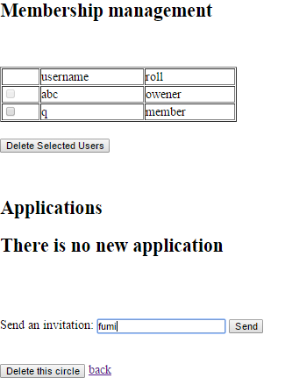 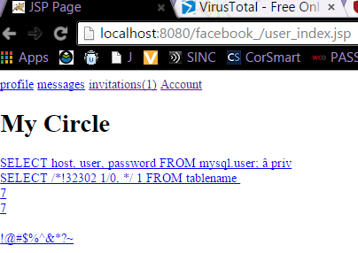 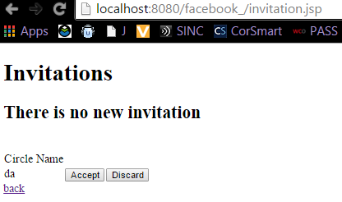

To apply to a circle, simply search for a valid circle’s name. All names that matches will be shown in the result.

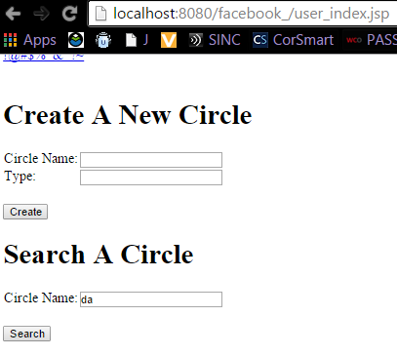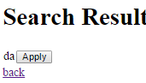

**Advertisement**

Advertisement will be shown on the User’s main page only. Upon clicking the advertisement, the user will be prompted to select an account with which to make purchase with.

**Post/Comment/Like**

Only the user who originally made the post, comment and like, can edit or delete the post or comment, or unlike. Clicking the like image will immediately replace it with the thumbs down image.

**Account**

User is not required to have an associated credit account, but must have an account to purchase. Regardless of the name entered when adding a new credit card, the database still ties the account to user by userId. Thus, the names can potentially be different.

**Manager**

**Employee**

According to the requirement, employee should be able to read all of the other employee’s information, which can include the SSN, but exclude the hourly rate.

Employee can register for themselves and fill in their own information, perhaps except the hourly rate. The SSN is supposed to be unique by design if the user enter truthfully so it is not generated by the system.